Netflix Dataset Findings:

- From initial inspection, it was identified that the average IMDB rating of media on Netflix had a trend of high ratings for media with release dates between the 1980s and 2000s, with an average of 7 and 7.2 in the 1980s and 1990s. This suggests that the platform's best-rated media tend to have release dates before the 21st century.

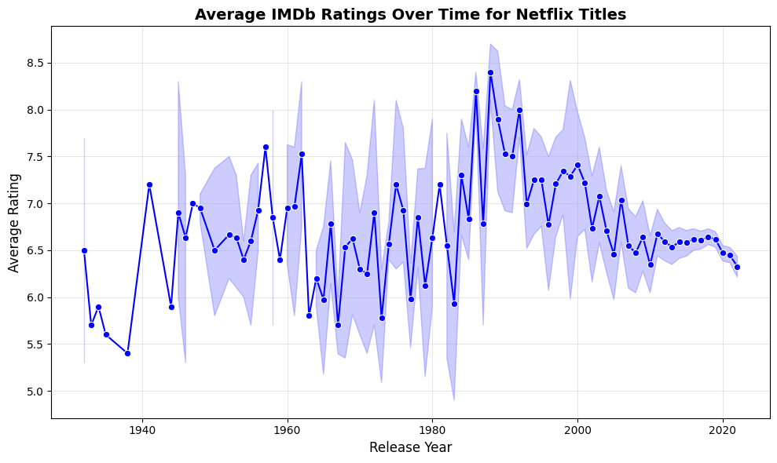

- Can observe that overall, the best performing genres are both documentary and animation, with averages of 7 and 6.5. The top 9-rated media on the platform all originate from the 20th century, with all scoring 9.2 or higher on IMDb.

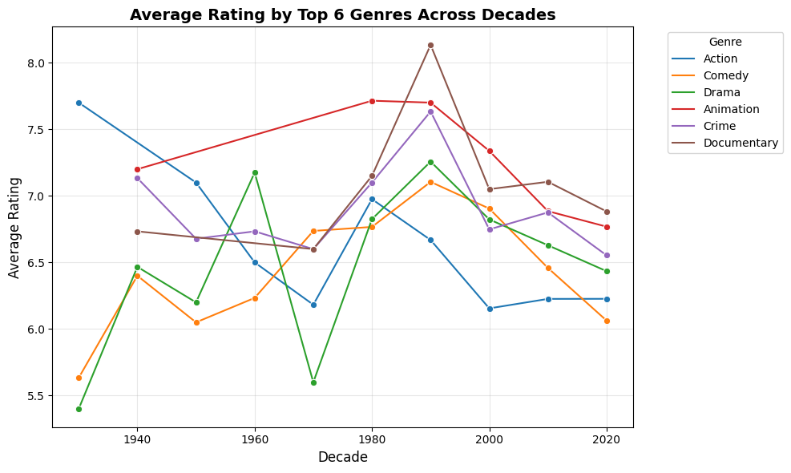
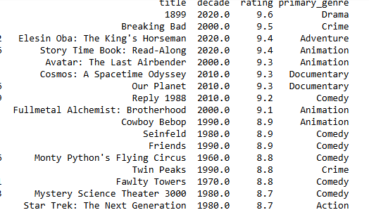

Insight:
Overall, older media, or “classics,” tend to be more critically acclaimed, while newer releases show a wider range of ratings, indicating mixed reviews. The most common top-rated genre across the dataset was documentaries.

